

Order and label my baby photos! I’ve included some words to help you.

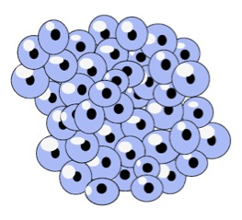

The t_________ starts growing l_______.

The f___________ grows up into a f___.

Its t____ shrinks.

They hatch into t __________s.

Female f______s lay f_____________.

The t________ grows into a baby f_______ called a f___________.