L.O. To recall key events from a narrative.
Story Mountain for: _____________________________________________ Name: ________________________________
Problem
________________________________________________________________________________________________________________________________________
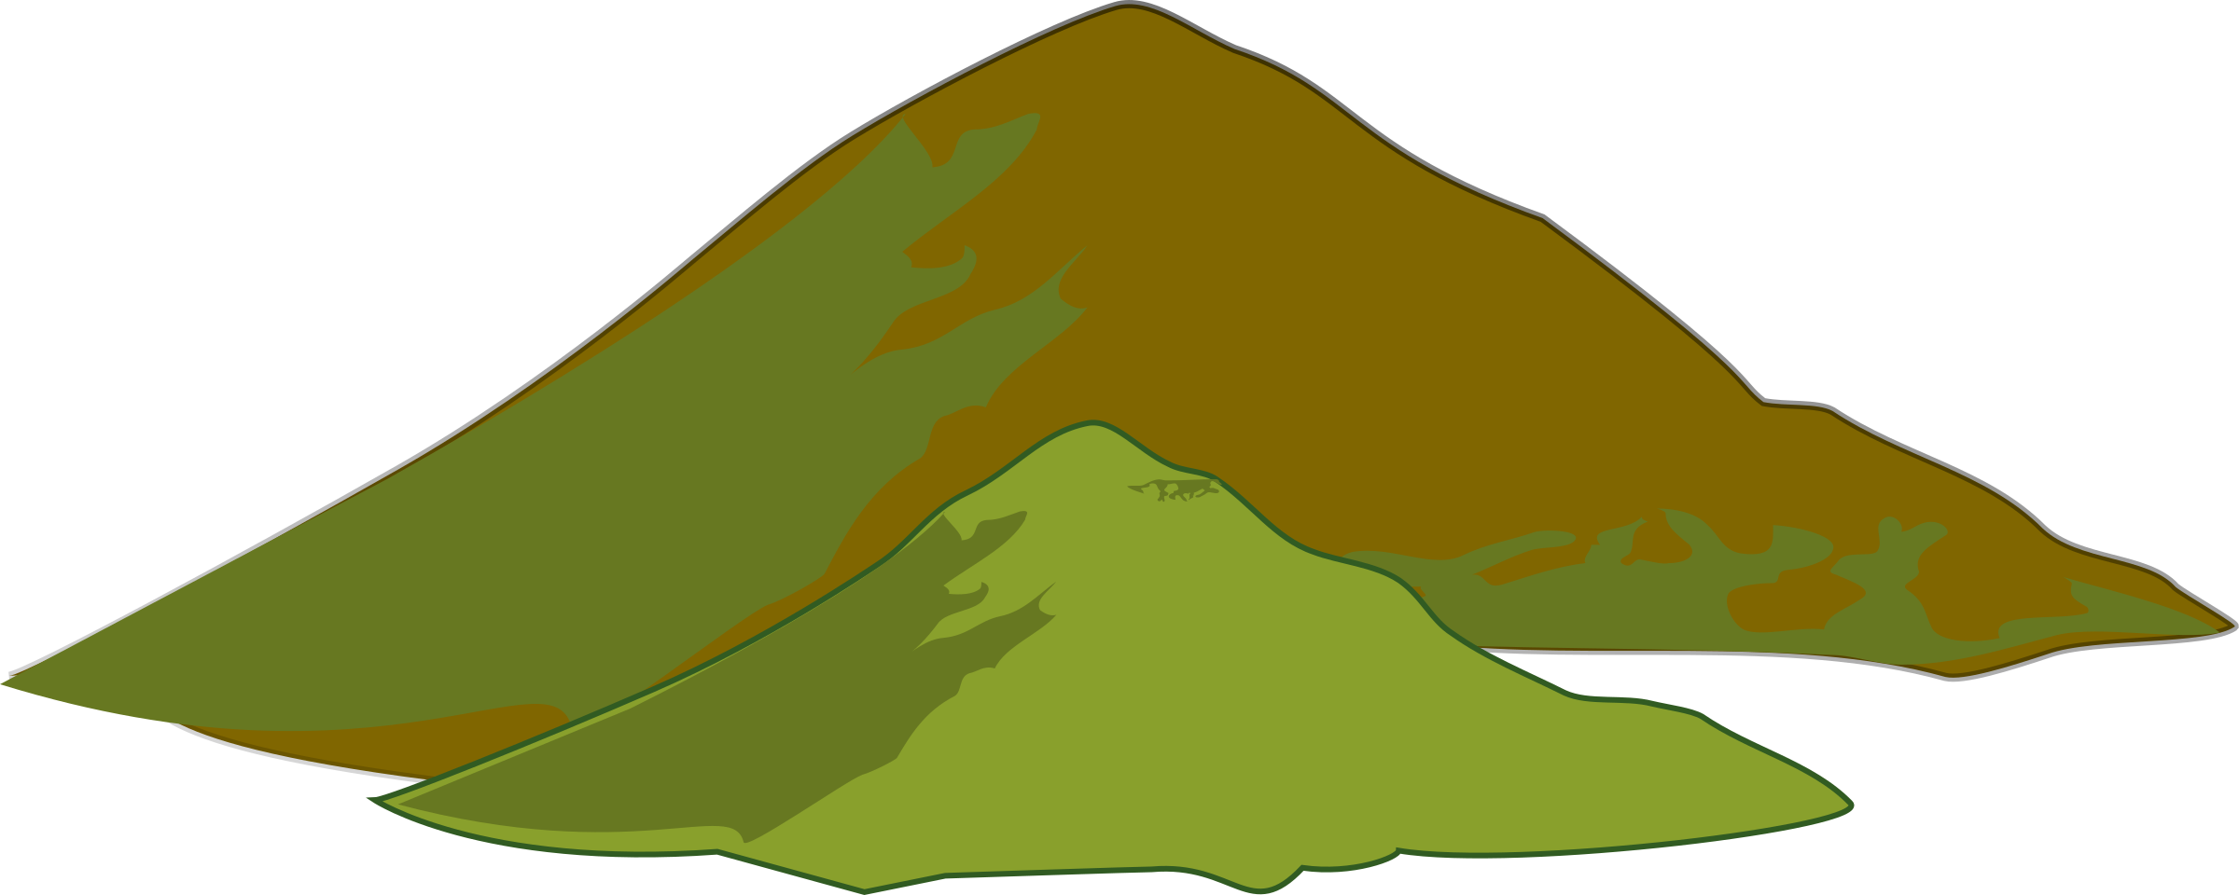
Story Mountain
Build Up
________________________________________________________________________________________________________________________________________
Characters

Settings

Resolution
________________________________________________________________________________________________________________________________________
Ending
________________________________________________________________________________________________________________________________________
Introduction
________________________________________________________________________________________________________________________________________

